Quang Huynh’s Post-Death Wishes

1. My name is Quang Huynh, and I was born in Vietnam on December 22nd, 2004 at 5:55 A.M. I have a traditional Vietnamese name, which my mother chose for me. My full name is Quang Trien Huynh, and it means pure and adventureous.
2. A positive impact through writing a pre-arrangement is having your wishes fulfilled after your death. You get to choose what happens to your own body and have trusted loved ones. Furthermore, your loved ones can know for certain that they are fulfilling your wishes, so they don’t worry about guessing it or not doing what you wanted.
3. In Ms. Bernas’s Life and Death class, I learned that by donating an organ, 8 lives can be saved. Then, I believe everyone should arrange to have their organs donated after their death and that it is selfish to not donate. Those who need organs can be saved through your donation.

|  |  |  |
| --- | --- | --- |
| Options | Explanation | Price w/ source |
| Ground burial | A traditional burial where a deceased individual lays in a casket and gets buried 6 feet underground. | At Harris Funeral Home, a simple burial costs $3,610. |
| Mausoleum | A structure that holds multiple deceased people, usually a family. | At Rome Monuments, a 9 Crypt Chapel Walk-in Mausoleum goes for $180,000. |
| Cremation | The disposal of a dead body by burning it to ashes | Genesse Valley Cremation services start at $995. |

a) After my death, my plan for my body is a cremation. I would like to be cremated and give the ashes to my loved ones. My body gets burned in a retort or cremator and what remains are the ashes. At the Genessee Valley Cremation, their price for cremation goes for $995. I want my body to be cremated because my loved ones get the freedom to do whatever they want with my ashes.

6.

|  |  |  |
| --- | --- | --- |
| Options | Explanation | Price w/ source |
| Funeral | Funeral Service is a service held to memorialize a deceased person with their body present. | Bartoleomeo.com - $4,630 |
| Memorial service | A Memorial Service is a service held to memorialize a deceased person without their body present. | Harris Funeral Home - $3,025 |

a) The type of ceremony I would like is a memorial service because if I am cremated, there will be no body present. I will go with a simple cremation with memorial service package. At the memorial service, I plan to share my ashes with my loved ones.

7. a) First, bodies that are delivered to a crematory must be in a leakproof, combustible and rigid container that encases the body. Then, in New York State, there is no law about the disposal of human remains. Remains can be scattered, buried, or kept at home.

b) I would like to be cremated and put in an urn. My family can choose whatever they want to do with my remains. They can make my ashes into jewelry, grow a tree out of them, fireworks, scatter them, anything they desire. It will be their choice.

8. My urn will be simple and elegant. I wish for a maroon color with floral patterns and a gold accent.

9. My urn carrier will be my eldest child. Because they are the oldest, they hold the responsibility and honor to be my urn carrier.

10.

a) An obituary is a notice of somebody’s death. It is meant to inform others about one’s death and a short story about their life.

b) I’d like to place my obituary as a bench at Ontario Lake View in Webster. It will cost in the price range of $500-$1500 to get a bench with a plaque.

c) In my obituary, I would like to include my birth town, my full name, birthday, town of residence, a list of my close surviving family members, and my hobbies.

11.

a) I prefer a plaque over a headstone to honor my life.

b) “In Loving Memory of Quang Huynh. Overcome laziness and conquer your fears.” I chose this wording because it is a little personal lesson, and it is simple.

12.

a) The types of readings I have will be from a Buddhism. This is because my family is Buddhist, and I would like to continue the tradition. Buddhist readings are simple yet powerful. A loved one will be reading the selections.

13.

a) A eulogy is a speech or writing that praises a dead person. It is important to include a eulogy because it is a great way to honor the memory of a loved one.

b) My child or grandchild will read my eulogy. My eulogy reads,

“Quang Huynh was a truly kind and respectful person. He was always there for his friends, always ready to lend an ear and offer his support. He was a good listener and a true friend to all who knew him. His parents were loving and supportive, and Quang was always grateful for the love and guidance they provided.

Quang was a person who always saw the best in others, and he worked hard to bring out the best in himself. He was always willing to go the extra mile, whether for his friends, family, or community. He was a light in the lives of those around him, and his kindness and respect will be deeply missed.

Quang leaves behind a legacy of love and kindness that will live on in the hearts of all who knew him. May he rest in peace, and may the memories of his goodness live on forever.”

14.

One of my favorite childhood memories was having the freedom to do anything without stress. I could wake up and feel excited for the day, not knowing what was going to happen next. I went outside every day, rode my bike around the sketchy neighborhood, and made friends. The world felt colorful and pure. I remember my dad was always giving me new toys and showing off his cars. I'm glad I got to sit in his supra and experience its power in my life. That thing was a beast. It made 700 horsepower with a gt67 turbo at only 25psi. My dad thought it was so dangerous and he dreaded the thought of me not having a father figure, so he quit his passion for family.

In elementary school and middle school were the prime days of my life. Every day after school, I did about 20 minutes of homework and then played videogames. Moreover, I went over to my friend, Jason Murray’s house, which was a block away from my house to skateboard every day. We filmed every moment of it and made fun memories. In 3rd grade, the hit videogame, Grand Theft Auto 5 just came out and I bought it at Walmart for the PlayStation 3. The hype and excitement for the game was worth it. There was so much to do.

When I was a kid, I had a passion for cars, guns, and computers. Growing up, I still have those passions and I owe it to my mom and dad, who were always there for me. They allowed me to do whatever I liked and were very understanding.

15.

For music choices, I would choose something slow and bumpy. I would use Heart to Heart by Mac DeMarco because I love his music and would love to play it at my ceremony.

16.

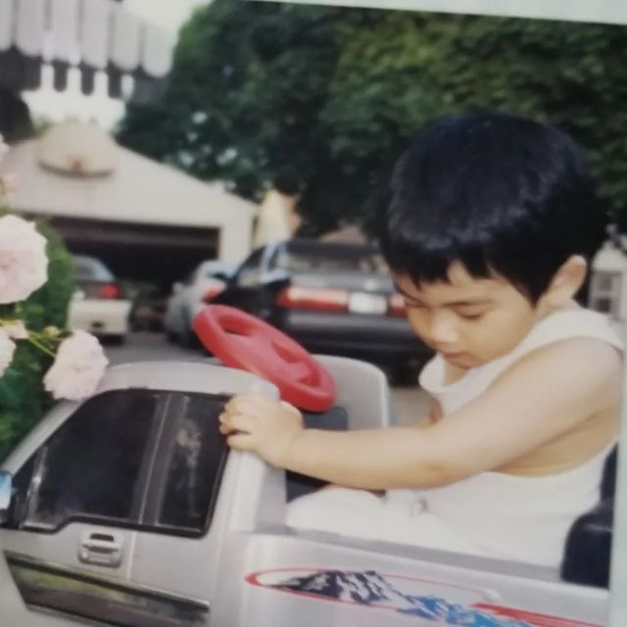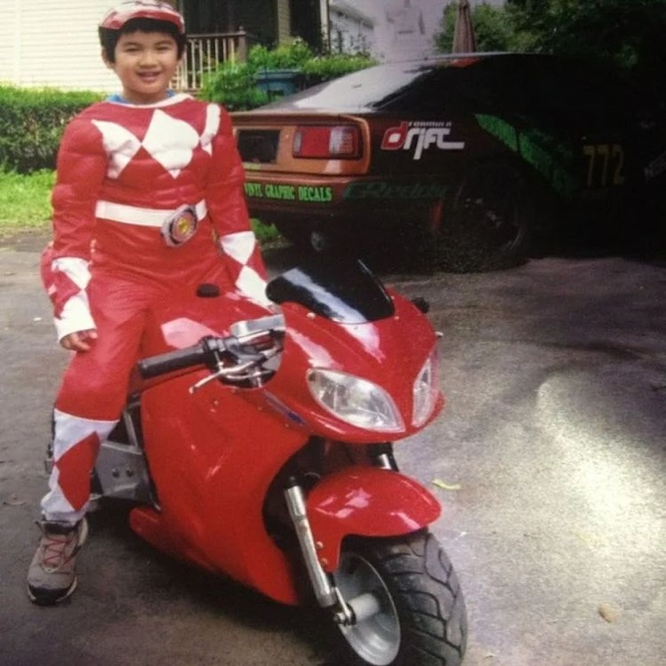

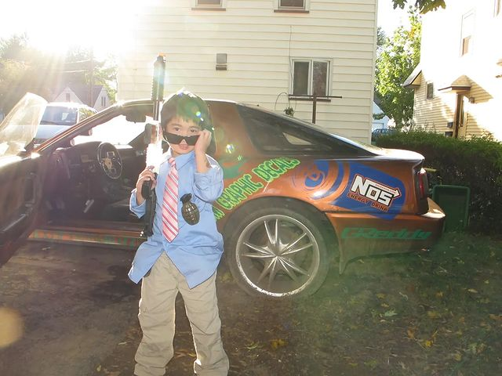

I would probably have more photos when I actually have my memorial service, but these are some pictures I cooked up. I chose these because they represent who I am, and I will have them displayed on TVs around the room.

17.

I am proud to say that I have had many accomplishments in my life. Getting accepted into RIT with $0 tuition is big on that list. This was due to my academic studies and determination. Furthermore, I bought my dream cars at the age of 17. This was done through my business where I detail cars in 2021-2022 during the winter and summer months. Furthermore, I was ranked #1 in Fortnite for several days and in a global Aim Labs tournament with over 3 million people participating, I managed to land 7th place in an aim challenge.

18.

I would donate to the National Children's Cancer Society because it hits close to home. My non-verbal autistic brother had leukemia when he was 2 and I felt bad for the pain he was in during those times. The National Children's Cancer Society helps to fund families to provide excellent care and treatment for their children.

19.

To start off, a cremation would cost around $800. Then, an urn would be around $1,000. To honor my death and to save money, a group gathering would be better than spending thousands on a memorial service. I think a price limit would be $5,000 and the aspect that is the most important to me during the celebration is the family spending time together and having a good time. Even at a death party. I would have used my retirement funds or paid for my services myself to save the burden of my family paying for it.

20.

I would invite and notify close friends and people who had a significant impact on my life. I plan to notify them through email, text, or a big group chat.

21.

All of my documents concerning my death will be placed in a folder in a bank or safe location where only my family members know.

Last Will and Testament, Power of Attorney, Trust, HIPAA Release, Living Will, Healthcare Power of Attorney, and Letter of Intent.

22.

"In the midst of chaos, there is also opportunity.”